

***Operating Lease Support System Phase-2 Project***

***for***

****

***Functional Specification***

***FC.AB.2.1 Manage SKD***

Revision 1.0

**PT. Berlian Sistem Informasi**

KTB Annex Bld. 4th Floor, Jl. Jend. A. Yani. Pulomas,

Tel. +62 21 4786 7575 (Hunting) Fax. +62 21 4714964 www.bsi.co.id

Document Control

|  |  |
| --- | --- |
| **Author** | Raymond |
| **File Name** |  |
| **Path** |  |
| **Number of Page** |  |

Revision History

|  |  |  |  |
| --- | --- | --- | --- |
| **Date** | **Revision** | **Description** | **Author** |
| 1/10/2015 | 0.0 | Initialization | Raymond |
| 22/10/2015 | 0.1 | * Adding Functional Specification for List of Visit Customer Survey * Adding Functional Specification for Create Visit Customer Survey * Adding Functional Specification for Edit Visit Customer Survey * Adding Functional Specification for View Visit Customer Survey * Adding Functional Specification for Print Visit Customer Survey | Raymond |
| 23/11/2015 | 0.2 | * QCO review | Raymond |
| 11/12/2015 | 0.3 | * Revision of review | Raymond |

Distribution List

|  |  |  |
| --- | --- | --- |
| Name | Organization | Roles |
| Mr. Jin Nishimura | Dipo Star Finance, PT | DSF Project Director |
| Mr. Shinji Hosokawa | Dipo Star Finance, PT | DSF Project Advisor |
| Mr. Ahmad Fikri | Dipo Star Finance, PT | DSF Project Advisor |
| Mr. Abdul Somad | Dipo Star Finance, PT | DSF Project Manager |
| Mr. Delta Riangga | Dipo Star Finance, PT | DSF Key User |
| Mr. Mochamad Idris | Dipo Star Finance, PT | DSF Key User |
| Mrs. Herni Hembang | Dipo Star Finance, PT | DSF Key User |
| Mr. Junaidi Didy | Dipo Star Finance, PT | DSF Key User |
| Mr. Dedi Supriyadi | Dipo Star Finance,PT | DSF Key User |
| Mrs. Elke Hilviana | Dipo Star Finance,PT | DSF Key User |
| Mr. Mukhlis Ibrahim | Dipo Star Finance, PT | DSF IT Department Representative |
| Mr. Roby Wijaya | Dipo Star Finance, PT | DSF IT Department Representative |
| Mr. Daiki Kamada | Berlian Sistem Informasi, PT | BSI Project Director |
| Mr. Feri Irawan | Berlian Sistem Informasi, PT | BSI Project Advisor |
| Mr. Grand Zah Putra | Berlian Sistem Informasi, PT | BSI Project Manager |
| Mr. Raymond | Berlian Sistem Informasi, PT | BSI Business Analyst |

Document Approval

By signing this document I acknowledge I have read the document and give the Project Management Team approval to proceed.

|  |  |  |  |
| --- | --- | --- | --- |
| Role | Name | Signature | Date |
| DSF Project Director | Mr. Jin Nishimura |  |  |
| DSF Project Advisor | Mr. Ahmad Fikri |  |  |
| DSF Project Manager | Mr. Abdul Somad |  |  |
| DSF IT Department Representative | Mr. Mukhlis Ibrahim |  |  |
| BSI Project Director | Mr. Daiki Kamada |  |  |
| BSI Project Advisor | Mr. Feri Irawan |  |  |
| BSI Project Manager | Mr. Grand Zah Putra |  |  |
| BSI Business Analyst | Mr. Raymond |  |  |

Table of Contents

Document Control 2

Revision History 2

Distribution List 3

Document Approval 4

1. Introduction 6

1.1 Purpose 6

1.2 Scope 6

1.3 Definition, Acronyms, and Abbreviations 6

2.4 References 6

2. Configuration 7

3. Specification Detail: FC.AB.2.1 Manage SKD 7

3.1 Purpose 7

3.2 Screen of Configuration Access 7

3.3 Screen Functionality 7

3.4 Operation Flow 8

3.5 Screen Design 8

3.6 Component Screen Functionality 13

3.7 Operation Description 20

3.8 Data Structure 30

3.9 Screen Item List 39

1. Introduction
   1. Purpose

Functional Specification is a document to describe the detail of functions system which includes screen design, report, and logic formula. This document will be used for system development.

* 1. Scope

Functional Specification Document contains screen design, screen functionality, process flow, and data structure of FC.AB.2.1 Manage SKD for Phase-2

Here are the scope for FC.AB.2.1 Manage SKD:

1. **AB.2.1.3 Create SKD**

To create a SKD data

1. **AB.2.1.4 Edit SKD**

To edit a draft document of SKD

1. **AB.2.1.5 Submit SKD**

To submit SKD which will be approved by DSF Authorized Person

Output from this document is:

1. RPT.AB.2.1 SKD Form
2. PF.AB.2.1 SKD Report
   1. Definition, Acronyms, and Abbreviations
3. OPL = Operating Lease
4. DSF = Dipo Star Finance
5. BSI = Berlian Sistem Informasi
6. HOB = Head of Branch
7. HOD = Head of Department
8. RM = Regional Manager
9. SKD = Surat Keputusan Direksi/ Board of Director’s Decree
   1. References

This functional specification document refers to **“To Be Design” AB. Marketing Process**, module:

1. AB.2 SKD Process

* AB.2.1 SKD Creation of Operating Lease

1. Configuration

Here is the description of SKD Document numbering format which will be generated when PIC OPL HO/Branch clicks the Save as Draft button or Submit button on Create SKD screen.

The format of SKD Number is:

SKD Number : 000001/4/BRANCH/MONTH/YEAR

Description :

* The first 6 digits show the sequence number of the SKD document. This number will increments whenever new SKD document is created.
* The code ‘4’, is absolute for Operating Lease (OPL).
* The code ‘BRANCH’ will be substituted by Branch/DSF Office’s code, refers to Tb\_OPL\_Branch.BranchShortName
* The code ‘MONTH’ will be substituted by 2 digits of month when the SKD document is created.
* The code ‘YEAR’ will be substituted by 4 digits of year when the SKD document is created.

1. Specification Detail: FC.AB.2.1 Manage SKD
   1. Purpose

The screens used in Manage SKD are used to Create, Edit, and Submit the SKD and generate an output as a print form of the SKD Form

* 1. Screen of Configuration Access

Here are the access right for users:

|  |  |  |  |  |
| --- | --- | --- | --- | --- |
| ***User*** | ***Create*** | ***Read*** | ***Update*** | **Authorization** |
| Marketing Officer | V | V | V | V |
| Head of Branch | - | V | - | V |
| Head of Department | - | V | - | V |
| Regional Manager | - | V | - | V |
| Advisor | - | V | - | V |
| Director | - | V | - | V |
| President Director | - | V | - | V |
| Shareholder’s Meeting | - | V | - | V |

Legend :

V = Have the Access

* 1. Screen Functionality

1. Show lists of SKD record data
2. Create a SKD
3. Edit a draft document of SKD
4. View a SKD
5. Submit a SKD
6. Print a SKD Form
   1. Operation Flow

Below is operation flow for Monitoring and print unit preparation process refer to **To Be Design Document Marketing Process**, **AB.2.1 Board of Director’s Decree/ Surat Keputusan Direksi (SKD)**:

|  |  |
| --- | --- |
| **PIC PC** | **Process** |
|  | Quotation  (OPLQuotation)  D:\Users\bsi00815\Desktop\PrintScreen\SKD\SKD v3\SKD v4\SKD_Add.png  Supplier Master Data  (Supplier)    SKD  (Tb\_MKT\_SKD)  Note:  Source  Output (Stored Data) |

* 1. Screen Design
* *Initial Screen Manage SKD*

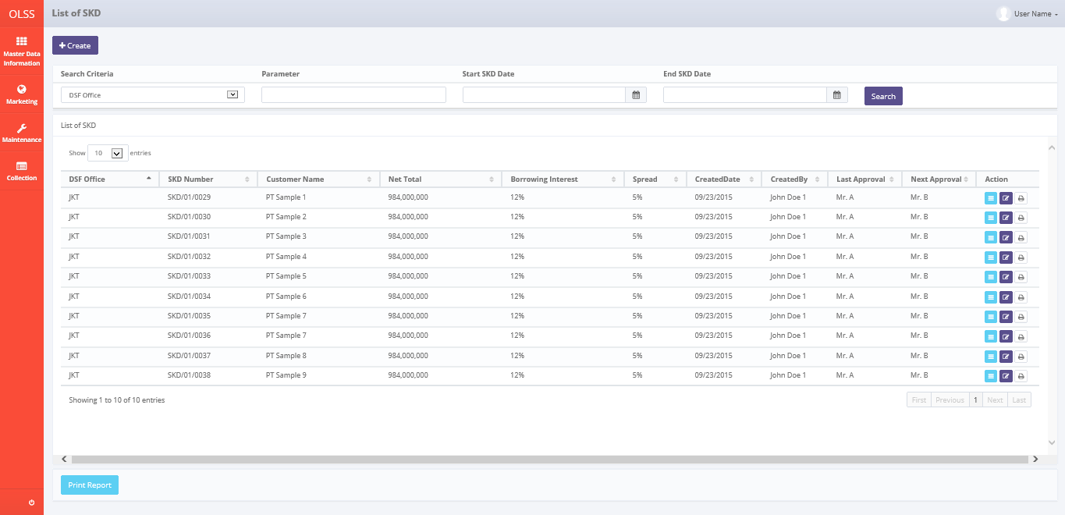

*Screen 1. List of SKD*

* *Create SKD*

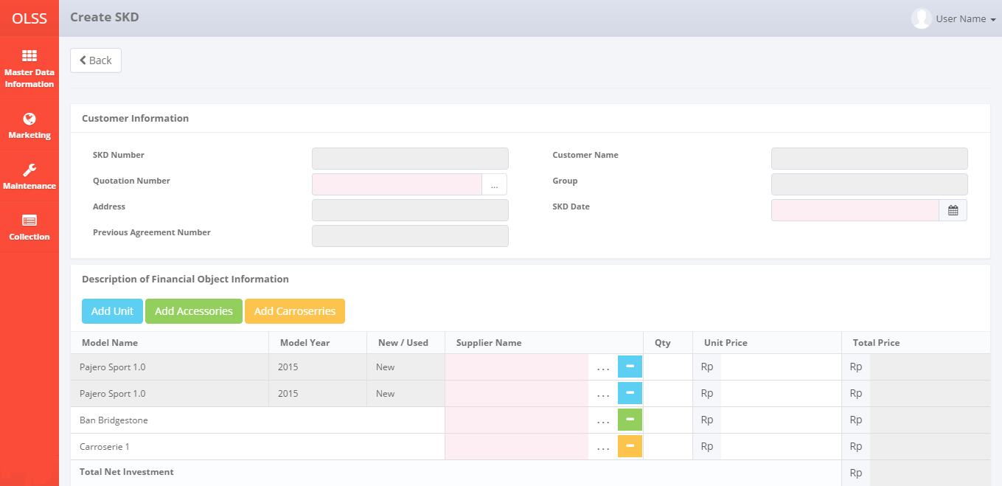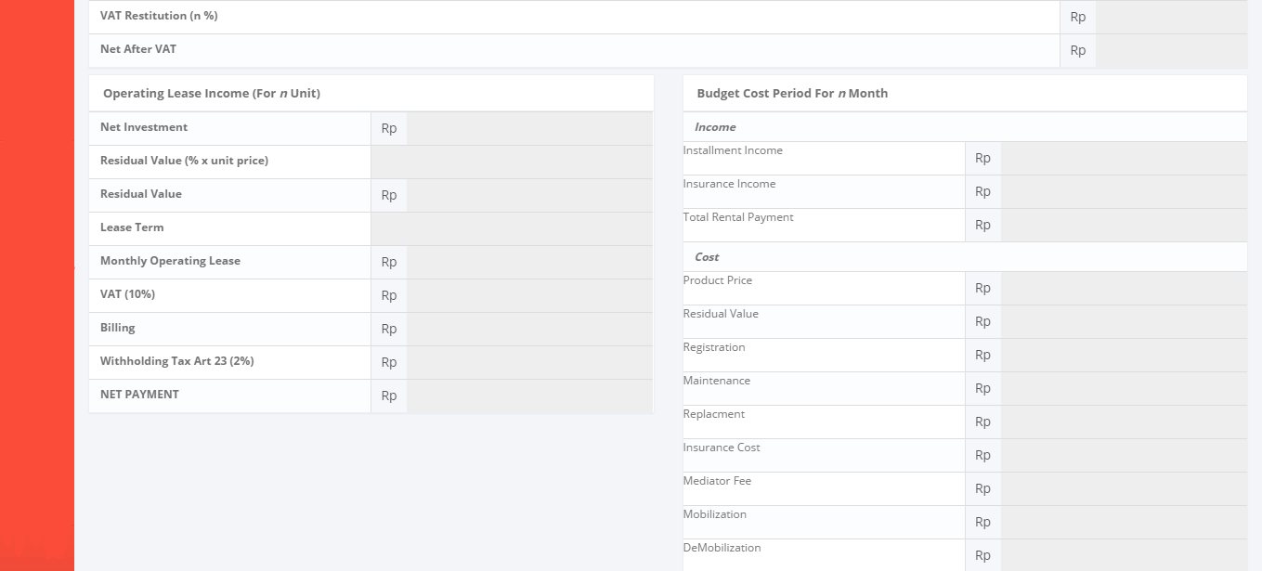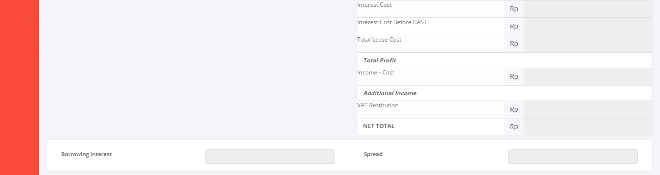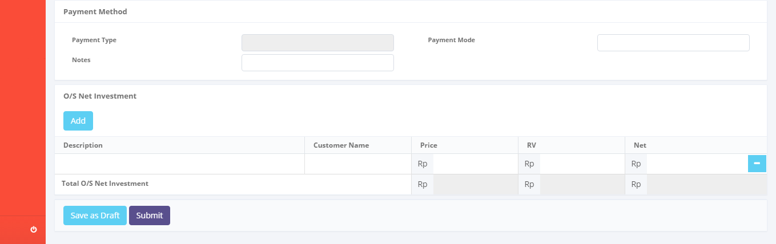

*Screen 2. Create SKD*

* *Edit SKD*

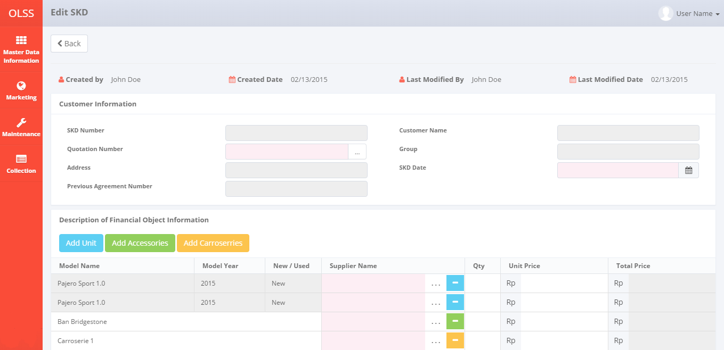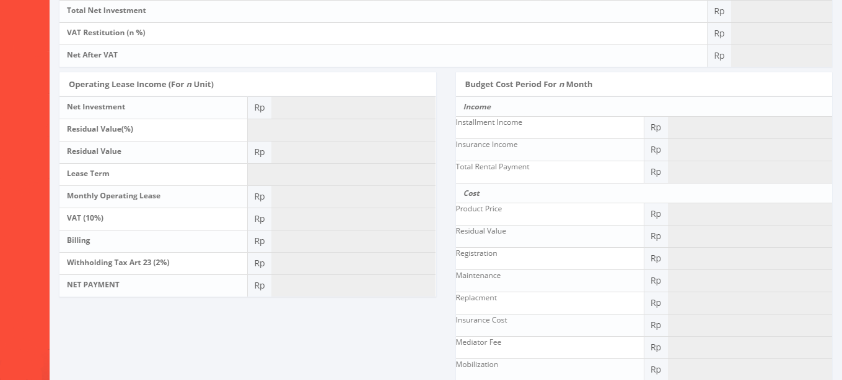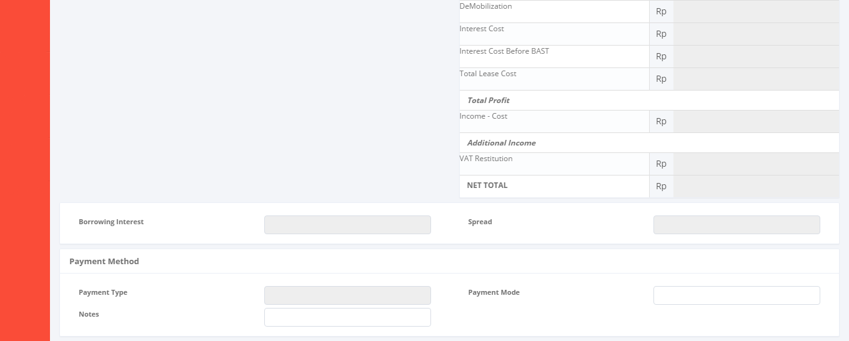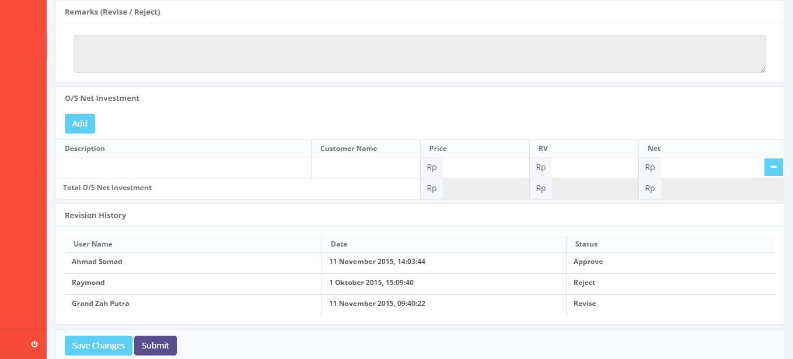

*Screen 3. Edit SKD*

* *View SKD*

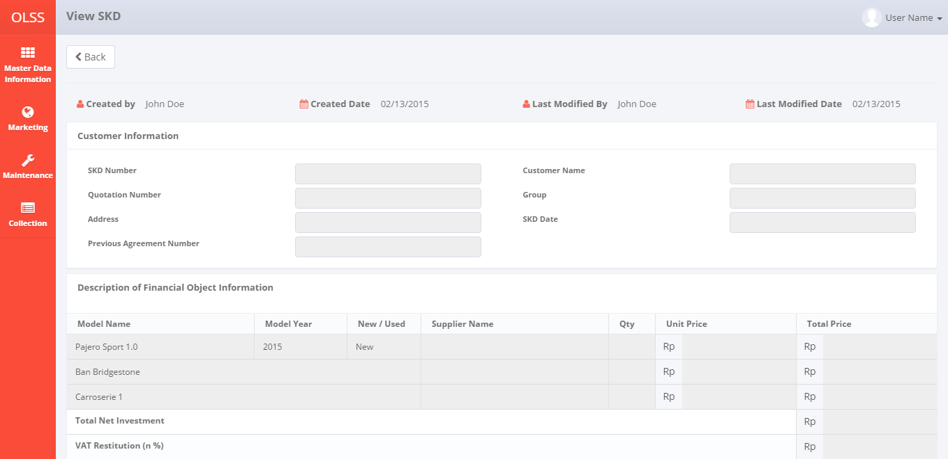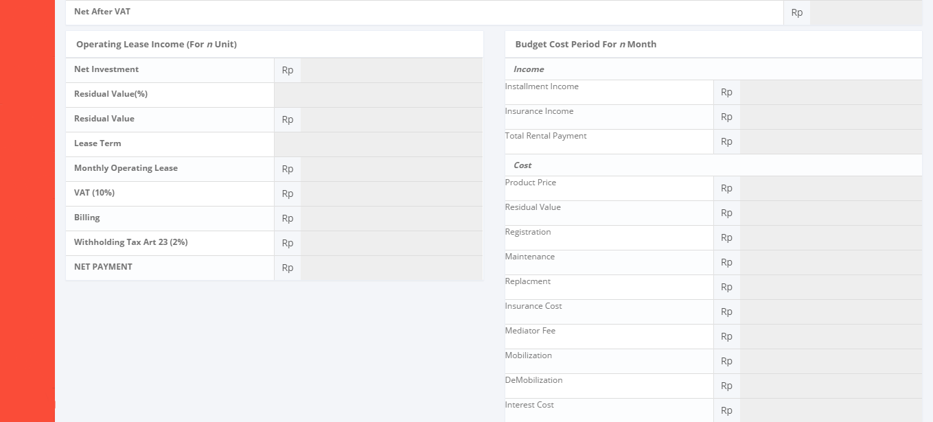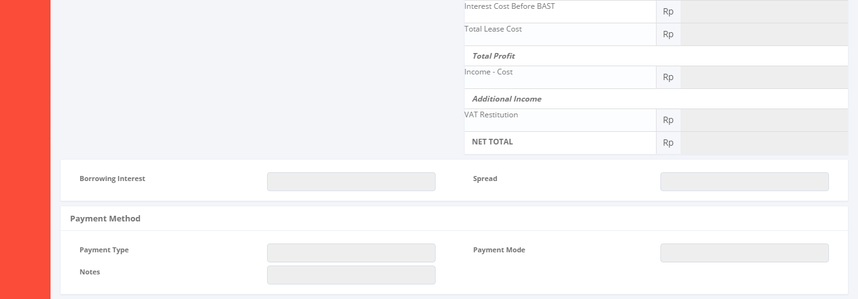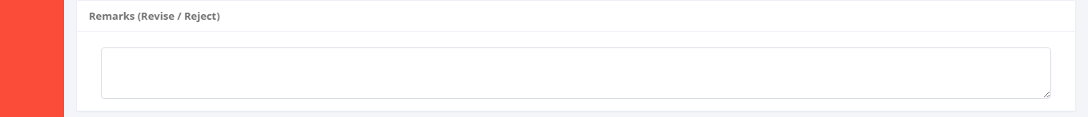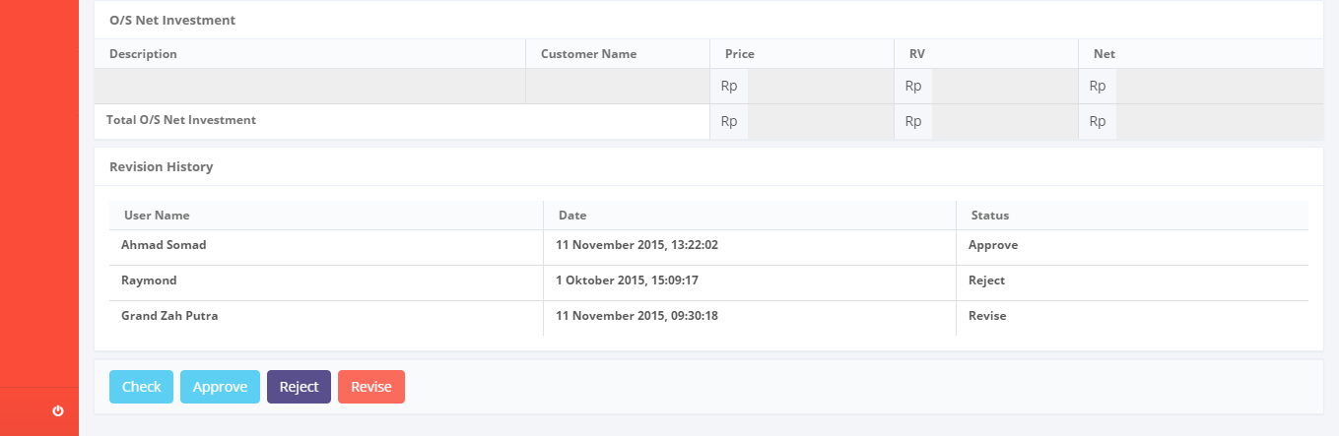

*Screen 4. View SKD*

* *Print Form SKD*

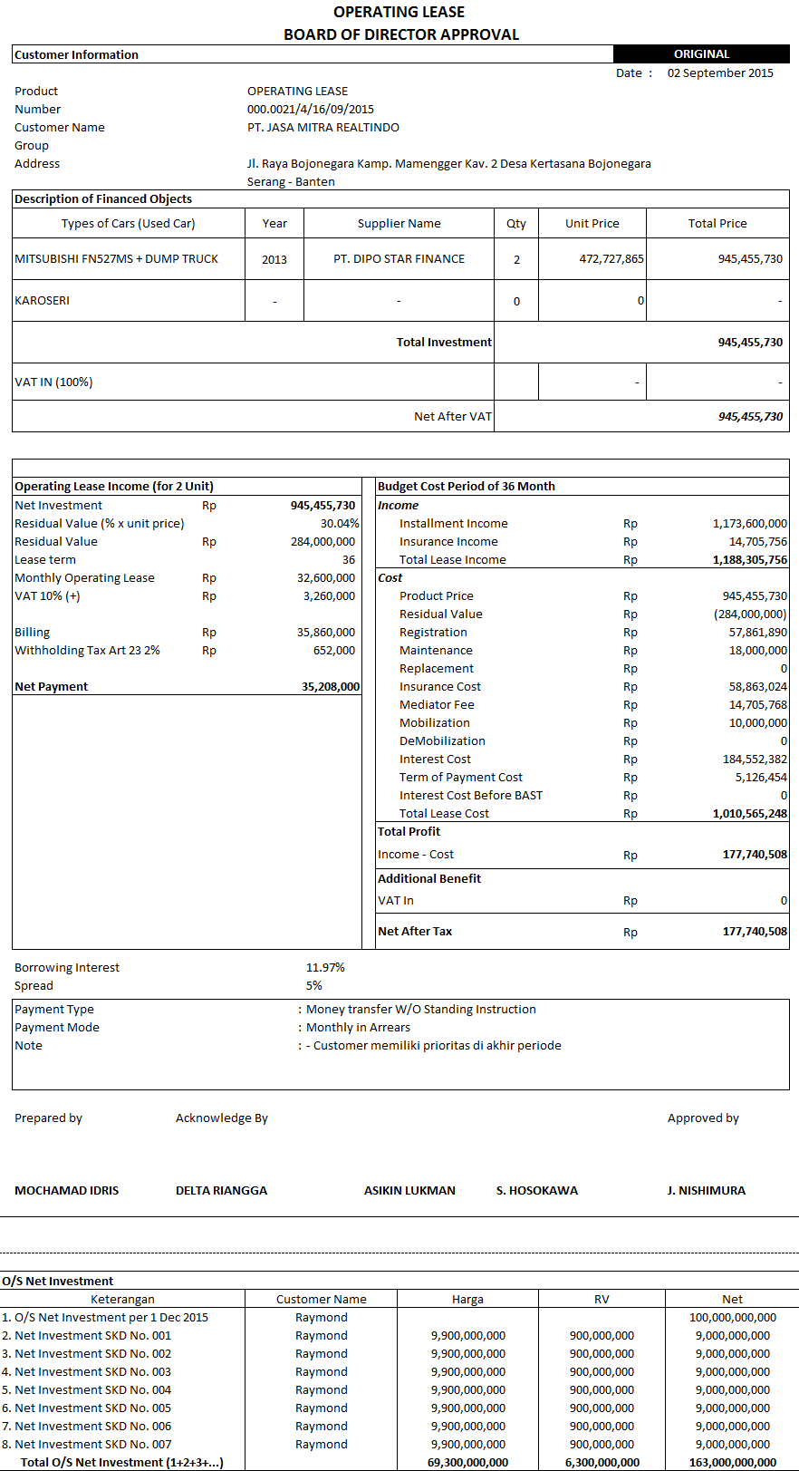

*Screen 6. Print Report SKD*

* *Notification after Save or Submit SKD*

D:\Users\bsi00815\AppData\Roaming\Skype\raymond_quicksilver\media_messaging\media_cache_v2\^A94AB712B1C684D2CC8BE16BF8EEACB385228C1EA42C432AEF^pimgpsh_fullsize_distr.jpg

*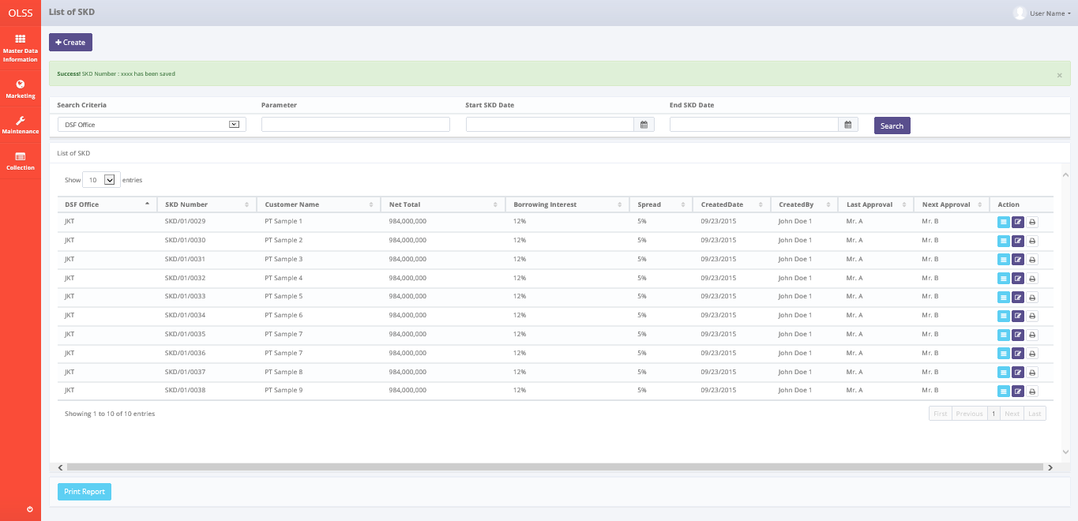*

*Screen 7. Save or Submit Notification*

* 1. Component Screen Functionality
  2. **List of SKD**

Here are the screen functions from each component in **Screen 1. List of SKD**:

|  |  |  |  |
| --- | --- | --- | --- |
| ***No*** | ***Component*** | ***Name*** | ***Function*** |
| **Header** | | | |
| 1 | Label | List of SKD | SKD Creation title |
| 2 | Button | Create SKD | To select the operation for searching |
| **Search Criteria** | | | |
| 3 | Drop down box | Search criteria | To select the category for searching criteria |
| 4 | Text box/ Date picker | Parameter | To input the value for searching criteria |
| 5 | Date picker | Start Period | To select the start date of record lists |
| 6 | Date picker | End Period | To select the end date of record lists |
| 7 | Button | Search | To do a search and showing lists according to criteria |
| **List of SKD** | | | |
| 8 | Button | Edit SKD | To show an editable screen of Visit Customer Survey draft which has been created |
| 9 | Button | View SKD | To show details of Visit Customer Survey |
| 10 | Button | Print Form SKD | To show a preview of Visit Customer Survey report document before print |
| 11 | Drop down box | Entries | To show entry number of lists |
| 12 | Label | Customer Name | Display Customer Name of SKD that has been created |
| 13 | Button | Customer Name | To sort in ascending or descending format |
| 14 | Label | SKD Number | Display SKD Number that has been created |
| 15 | Button | SKD Number | To sort in ascending or descending format |
| 16 | Label | Net Total | Display Net Total of a SKD |
| 17 | Button | Net Total | To sort in ascending or descending format |
| 18 | Label | Borrowing Interest | Display Borrowing Interest of a SKD |
| 19 | Button | Borrowing Interest | To sort in ascending or descending format |
| 20 | Label | Created By | Display Created By of a SKD |
| 21 | Button | Created By | To sort in ascending or descending format |
| 22 | Label | Created Date | Display Created Date of a SKD |
| 23 | Button | Created Date | To sort in ascending or descending format |
| 24 | Label | Spread | Display Status of Visit Customer Survey that has been created |
| 25 | Button | Spread | To sort in ascending or descending format |
| 26 | Label | Last Approval | Display Last Approval of a SKD |
| 27 | Button | Last Approval | To sort in ascending or descending format |
| 28 | Label | Next Approval | Display Next Approval of a SKD |
| 29 | Button | Next Approval | To sort in ascending or descending format |
| 30 | Label | Action | Display Edit, View, and Report button |
| 31 | Label | Showing 1 to *n* of *n* entries | Display the entries generated by search engine |
| 32 | Link | First Page | To show the first page entry |
| 33 | Link | Previous Page | To show the previous page entry |
| 34 | Link | Page Number | To show the page screen according the number |
| 35 | Link | Next Page | To show the next page entry |
| 36 | Link | Last Page | To show the last page entry |
| **Footer** | | | |
| 37 | Button | Print Report | To print the report from the lists of record |

* 1. **Create SKD**

Here are the screen functions from each component in **Screen 2. Create SKD**:

|  |  |  |  |
| --- | --- | --- | --- |
| ***No*** | ***Component*** | ***Name*** | ***Function*** |
| **Customer Information** | | | |
| 1 | Text Box | SKD Number | Displaying SKD Number created |
| 2 | Searching Box | Quotation Number | To generate searching screen for Quotation No |
| 3 | Text Box | Address | To input Address value |
| 4 | Text Box | Customer Name | To input Customer Name value |
| 5 | Text Box | Group | To input Group value |
| 6 | Date Picker | SKD Date | To input SKD created date value |
| 7 | Text Box | Previous Agreement Number | Displaying Previous Agreement Number |
| **Description of Financial Object Information** | | | |
| 8 | Text Box | Model Name | Displaying Model Name |
| 9 | Text Box | Model Year | Displaying Model Year |
| 10 | Text Box | New / Used | Displaying New / Used |
| 11 | Searching Box | Supplier Name | To generate searching screen for Supplier Name |
| 12 | Button | Add Unit | To add a row of supplier for an Unit |
| 13 | Button | Add Accessories | To add a row of supplier for an Unit |
| 14 | Button | Add Carrosserie | To add a row of supplier for an Unit |
| 15 | Button | Remove | To remove a row of supplier for an item |
| 16 | Text Box | Qty | Displaying Qty |
| 17 | Text Box | Unit Price | Displaying Unit Price |
| 18 | Text Box | Total Price | Displaying Total Price |
| 19 | Text Box | Delivery Fee | Displaying Delivery Fee |
| 20 | Text Box | Total Net Investment | Displaying Total Net Investment |
| **Operating Lease Income (For n Unit)** | | | |
| 21 | Text Box | Net Investment | Displaying Net Investment |
| 22 | Text Box | Residual Value(%) | Displaying Residual Value(%) |
| 23 | Text Box | Residual Value(Rp) | Displaying Residual Value(Rp) |
| 24 | Text Box | Lease Term | Displaying Lease Term |
| 25 | Text Box | Monthly Operating Lease | Displaying Monthly Operating Lease |
| 26 | Text Box | VAT (10%) | Displaying VAT (10%) |
| 27 | Text Box | Billing | Displaying Billing |
| 28 | Text Box | Witholding Tax Art 23 (10%) | Displaying Witholding Tax Art 23 (10%) |
| 29 | Text Box | NET PAYMENT | Displaying NET PAYMENT |
| **Budget Cost Period For n Month** | | | |
| 30 | Label | Income | Displaying Income field |
| 31 | Text Box | Total Rental Payment | Displaying Total Rental Payment |
| 32 | Label | Expense | Displaying Budget Cost Period For n Month field |
| 33 | Text Box | Interest | Displaying Interest |
| 34 | Text Box | Registration Value | Displaying Registration Value |
| 35 | Text Box | Insurance Premi | Displaying Insurance Premi |
| 36 | Text Box | Polis Insurance | Displaying Polis Insurance |
| 37 | Text Box | Mediator Fee | Displaying Mediator Fee |
| 38 | Text Box | Maintenance | Displaying Maintenance |
| 39 | Text Box | Accessories Expense | Displaying Accessories Expense |
| 40 | Text Box | Gain Value | Displaying Gain Value |
| 41 | Text Box | Total Expense | Displaying Total Expense |
| 42 | Label | Total Profit | Displaying Total Profit field |
| 43 | Text Box | (Total Income - Total Expense) | Displaying (Total Income - Total Expense) |
| 44 | Text Box | Borrowing Interest | Displaying Borrowing Interest |
| 45 | Text Box | Spread | Displaying Spread |
| **Payment Method** | | | |
| 46 | Text Box | Payment Type | Displaying Payment Type |
| 47 | Text Box | Payment Mode | Displaying Payment Mode |
| 48 | Text Box | Notes | Displaying Notes |
| **O/S Net Investment** | | | |
| 49 | Button | Add | To add a Net Investment data row |
| 50 | Button | Remove | To remove a Net Investment data row |
| 51 | Text Box | Description | To show the Description of SKD Net Investment data row |
| 52 | Text Box | Customer Name | To show Customer Name of the SKD Data in description |
| 53 | Text Box | Price | To show Price of the SKD Data in description |
| 54 | Text Box | RV | To show RV of the SKD Data in description |
| 55 | Text Box | Net | To show Net of the SKD Data in description |
| 56 | Text Box | Total O/S Net Investment for Price, RV, and Net | Total amount of Price, RV, and Net |
| **Footer** | | | |
| 57 | Label | Revision Log | Displaying revision log |
| 58 | Button | Save as Draft | To save information that has been inserted at SKD form as a draft |
| 59 | Button | Submit | To submit information that has been inserted at SKD form to the next level |

* 1. **Edit SKD**

Here are the screen functions from each component in **Screen 3. Edit SKD**:

*See Component Screen Specification - b. Create SKD with addition of these components :*

|  |  |  |  |
| --- | --- | --- | --- |
| ***No*** | ***Component*** | ***Name*** | ***Function*** |
| **Header** | | | |
| 1 | Label | Edit SKD | Edit SKD title |
| 2 | Label | Created By | Displaying Created By |
| 3 | Label | Created Date | Displaying Created Date |
| 4 | Label | Last Modified By | Displaying Last Modified By |
| 5 | Label | Last Modified Date | Displaying Last Modified Date |
| **Revision History** | | | |
| 6 | Label | Revision History | Revision History sub-title |
| 7 | Label | User Name | Displaying User Name |
| 8 | Label | Date | Displaying Date |
| 9 | Label | Status | Displaying Status |
| **Footer** | | | |
| 10 | Text Area | Remarks (Reject/ Revise) | Displaying remarks from rejection/ revision |
| 11 | Button | Save Changes | To save the inputted form as draft document |

*and also these components are not available in Edit SKD :*

|  |  |  |  |
| --- | --- | --- | --- |
| ***No*** | ***Component*** | ***Name*** | ***Function*** |
| **Header** | | | |
| 1 | Label | Create SKD | Create SKD title |
| **O/S Net Investment** | | | |
| 2 | Button | Add | To add a Net Investment data row |
| 3 | Button | Remove | To remove a Net Investment data row |
| **Footer** | | | |
| 4 | Button | Save as Draft | To save the inputted form as draft document |

* 1. **View SKD**

Here are the screen functions from each component in **Screen 4. View SKD**:

*See Component Screen Specification - b. Create SKD with addition of these components :*

|  |  |  |  |
| --- | --- | --- | --- |
| ***No*** | ***Component*** | ***Name*** | ***Function*** |
| **Header** | | | |
| 1 | Label | View SKD | View SKD title |
| 2 | Label | Created By | Displaying Created By |
| 3 | Label | Created Date | Displaying Created Date |
| 4 | Label | Last Modified By | Displaying Last Modified By |
| 5 | Label | Last Modified Date | Displaying Last Modified Date |
| **Revision History** | | | |
| 6 | Label | Revision History | Revision History sub-title |
| 7 | Label | User Name | Displaying User Name |
| 8 | Label | Date | Displaying Date |
| 9 | Label | Status | Displaying Status |
| **Footer** | | | |
| 10 | Text Area | Remarks (Reject/ Revise) | To input remarks of revision or rejection |
| 11 | Button | Check | To check a SKD |
| 12 | Button | Approve | To approve a SKD |
| 13 | Button | Reject | To reject a SKD |
| 14 | Button | Revise | To revise a SKD |

*and also these components are not available in View SKD :*

|  |  |  |  |
| --- | --- | --- | --- |
| ***No*** | ***Component*** | ***Name*** | ***Function*** |
| **Header** | | | |
| 1 | Label | Create SKD | Create SKD title |
| **O/S Net Investment** | | | |
| 2 | Button | Add | To add a Net Investment data row |
| 3 | Button | Remove | To remove a Net Investment data row |
| **Footer** | | | |
| 2 | Button | Save as Draft | To save the inputted form as draft document |
| 3 | Button | Submit | To submit the inputted form |

* 1. **Print Form SKD**

Here are the screen functions from each component in **Screen 5. Print Form SKD**:

|  |  |  |  |
| --- | --- | --- | --- |
| ***No*** | ***Component*** | ***Name*** | ***Function*** |
| **Header** | | | |
| 1 | Label | Print SKD | Print SKD title |
| 2 | Button | Back | Back to previous screen |
| 3 | Button | Print | To print the previewed document |
| 4 | Link | First Page | To show the first page |
| 5 | Link | Previous Page | To show the previous page |
| 6 | Text box | Page Number | To show the page screen according to the number |
| 7 | Link | Next Page | To show the next page |
| 8 | Link | Last Page | To show the last page |
| 9 | Text box | Search field | To input the keyword to be searched in the form page |
| 10 | Link | Find | To find the keyword in the search field |
| 11 | Link | Next | To move to the nect keyword found on the form page |
| 12 | Drop down box | Convert to excel/ pdf | To convert the document into excel/ pdf |
| 13 | Button | Refresh | To refresh the page |
| **Body page** | | | |
| 14 | Image preview | SKD Form | Displaying the preview of document |

* 1. Operation Description

|  |  |  |
| --- | --- | --- |
| **No.** | **Operation Name** | **Description** |
| 1 | Initial view of List of SKD | The screen for list of SKD:   1. Component Status;  |  |  |  |  | | --- | --- | --- | --- | | Component | Name/Caption | Status | Remark | | Drop down box | User Name | Active |  | | Label | List of SKD | Not Active |  | | Drop down box | Search criteria | Active |  | | Text box | Parameter | Active |  | | Button | Search | Active |  | | Button | Create SKD | Active |  | | Button | Edit SKD | Active |  | | Button | View SKD | Active |  | | Button | Print Report SKD | Active |  | | Button | Print Form SKD | Active |  | | Label | DSF Office | Not Active |  | | Label | SKD Number | Not Active |  | | Label | Customer Name | Not Active |  | | Label | Product Type | Not Active |  | | Label | Supplier Name | Not Active |  | | Label | Qty | Not Active |  | | Label | Net Total | Not Active |  | | Label | Borrowing Interest | Not Active |  | | Label | Spread | Not Active |  | | Label | Last Approval | Not Active |  | | Label | Next Approval | Not Active |  | | Label | Created Date | Not Active |  | | Label | Created By | Not Active |  | | Label | Status | Not Active |  | | Label | Action | Not Active |  | | Button | First Page | Active | Active depending on the current entry | | Button | Previous Page | Active | Active depending on the current entry | | Link | Page Number | Active | Active depending on the current entry | | Button | Next Page | Active | Active depending on the current entry | | Button | Last Page | Active | Active depending on the current entry | |
| 2 | Searching the List of SKD | Input:   1. Select searching criteria category (search criteria), searching criteria value (parameter), Start Period (Visit Date), and End Period (Visit Date) in the Search Field   D:\Users\bsi00815\AppData\Local\Microsoft\Windows\Temporary Internet Files\Content.Word\VCS_List.png  Constraint:   1. Search criteria only consists of SKD Number, Customer Name, Net Total, Borrowing Interest, Spread, Last Approval, and Next Approval (the same as the lists) generated from Tb\_OPL\_SearchCriteria mapping 2. End SKD Date can not be less than Start SKD Date (the End SKD Date will be locked for the date before Start SKD Date) 3. Start SKD Date can not be less than End SKD Date (the Start SKD Date will be locked for the date after End SKD Date) 4. Click on the Search button   D:\Users\bsi00815\AppData\Local\Microsoft\Windows\Temporary Internet Files\Content.Word\Visit Customer Survey Report.png   1. The screen will view the list of SKD according to criteria 2. Select number of show list entries: 10, 25, 50, and 100 and click the page for viewing more data.   Process:   1. After clicking the search button, the system will get the data from Tb\_MKT\_SKD table and OPLCalculation table to be displayed in the list   Output:   1. Display list data of SKD   **NB:The approval status can be monitored by seeing the last approval and next approval column. User with his/her name attached in last approval column is the latest person to approve and user with his/her name attached in next approval column is the next person to approve the document.** |
| 3 | Initial view of Create SKD | The screen for Create SKD:   1. Status component;  |  |  |  |  | | --- | --- | --- | --- | | Component | Name/Caption | Status | Remark | | Label | Customer Information | Not Active |  | | Text Box | SKD Number | Not Active |  | | Searching Box | Quotation Number | Active | Mandatory field depicted in red text box | | Text Box | Address | Not Active |  | | Text Box | Customer Name | Not Active |  | | Text Box | Group | Not Active |  | | Date Picker | SKD Date | Active | Mandatory field depicted in red text box | | Text Box | Previous Agreement Number | Not Active |  | | Label | Description of Financial Object Information | Not Active |  | | Text Box | Model Name | Not Active |  | | Text Box | Model Year | Not Active |  | | Text Box | New / Used | Not Active |  | | Searching Box | Supplier Name | Active | Mandatory field depicted in red text box | | Button | Add Unit | Active |  | | Button | Add Accessories | Active |  | | Button | Add Carrosserie | Active |  | | Button | Remove | Active |  | | Text Box | Qty | Active |  | | Text Box | Unit Price | Not Active |  | | Text Box | Total Price | Not Active |  | | Text Box | Total Net Investment | Not Active |  | | Text Box | VAT Restitution (n%) | Not Active |  | | Text Box | Net after VAT | Not Active |  | | Label | Operating Lease Income (For n Unit) | Not Active |  | | Text Box | Net Investment | Not Active |  | | Text Box | Residual Value(%) | Not Active |  | | Text Box | Residual Value(Rp) | Not Active |  | | Text Box | Lease Term | Not Active |  | | Text Box | Monthly Operating Lease | Not Active |  | | Text Box | VAT (10%) | Not Active |  | | Text Box | Billing | Not Active |  | | Text Box | Withholding Tax Art 23 (10%) | Not Active |  | | Text Box | NET PAYMENT | Not Active |  | | Label | Budget Cost Period For n Month | Not Active |  | | Label | Income | Not Active |  | | Text Box | Total Rental Payment | Not Active |  | | Label | Expense | Not Active |  | | Text Box | Interest | Not Active |  | | Text Box | Registration Value | Not Active |  | | Text Box | Insurance Premi | Not Active |  | | Text Box | Polis Insurance | Not Active |  | | Text Box | Mediator Fee | Not Active |  | | Text Box | Maintenance | Not Active |  | | Text Box | Accessories Expense | Not Active |  | | Text Box | Gain Value | Not Active |  | | Text Box | Total Expense | Not Active |  | | Label | Total Profit | Not Active |  | | Text Box | (Total Income - Total Expense) | Not Active |  | | Text Box | Borrowing Interest | Not Active |  | | Text Box | Spread | Not Active |  | | Label | Payment Method | Not Active |  | | Text Box | Payment Type | Not Active |  | | Text Box | Payment Mode | Not Active |  | | Text Box | Notes | Active |  | | Button | Save as Draft | Active |  | | Button | Submit | Active |  | |
| 4 | Create SKD | Input   1. Click the button Create SKD on the List of SKD screen      1. Input the following field:  * Quotation No * SKD Date * Supplier Name * Qty * O/S Investment   Constraints:   1. Inputting Qty will trigger a hint to input the field with only number 2. Hint “24 hours format” will appear if the user clicked onto the field SKD Date 3. Every field inputted cannot exceed maximum length defined in database system 4. If there are cases which require multiple supplier to provide the item, it is possible to add a row of the unit (accessories and carroserrie will follow the number of row) and define the qty needed for the supplier to provide 5. Addition of Supplier of Unit, Accessories details, and Carroserrie details can be done by clicking Add button for each corresponding item 6. From step 2, click on Save as Draft button to save the document in draft status   D:\Users\bsi00815\AppData\Local\Microsoft\Windows\Temporary Internet Files\Content.Word\VCS_Create.png  Constraint:   1. Clicking the button will trigger a pop up screen for validation “**Are you sure you want to Save?**” 2. If “Yes” is clicked (pop up screen) with any of the field still hasn’t meet the validation criteria, every notification message for validation below the field will be generated (notification “This field is required” for mandatory field) 3. A validation will appear after clicking “Yes” of confirmation for total Qty of Accessories and Carrosserie in which Qty of one type of Accessories or Qty of one type of Carrosserie cannot exceed the total Qty of Unit (ex: If Unit Qty = 5, then Accessories Qty <= 5 for each type of Accessories, and also Carrosserie Qty <= 5 for each type of Carrosserie) 4. From step 2, click on Submit button to submit the document for next process and change the status of document into Submitted   D:\Users\bsi00815\AppData\Local\Microsoft\Windows\Temporary Internet Files\Content.Word\VCS_Edit.png  Constraint:   1. Clicking the button will trigger a pop up screen for validation “**Are you sure you want to Submit?**” 2. If “Yes” is clicked (pop up screen) with any of the field still hasn’t meet the validation criteria, every notification message for validation below the field will be generated (notification “This field is required” for mandatory field) 3. A validation will appear after clicking “Yes” of confirmation for total Qty of Accessories and Carrosserie in which Qty of one type of Accessories or Qty of one type of Carrosserie cannot exceed the total Qty of Unit (ex: If Unit Qty = 5, then Accessories Qty <= 5 for each type of Accessories, and also Carrosserie Qty <= 5 for each type of Carrosserie)   Process:   1. Inputting Quotation No will get data for all Entity (except SKD Date, Supplier Name, Quantity, and Notes) from Tb\_MKT\_OPLCalculation 2. Qty of Accessories and Carroserrie as part of item attached to unit will follow the qty of the unit itself 3. Formulation will auto calculate in the form for each input that affect the formula (**refer to 3.8 data structure**) 4. Revision Log will be inserted with the User Name, Date, and Status of the last activity into Tb\_MKT\_SKD\_History   Status consists of:   * Update (when button Save as Draft or Save Changes is clicked) * Submit (when button Submit is clicked) * Check (when button Check is clicked) * Approve (when button Approve is clicked) * Reject (when button Reject is clicked) * Revise (when button Revise is clicked)  1. O/S Net Investment initially will be inserted with Price (Net after VAT) of current product, Residual Value (Residual Value) of current product, and Net Investment (Net after VAT – Residual Value) of current product   Output:   1. By clicking save as draft or submit, the inputted data will be inserted into Tb\_MKT\_SKD table and generate SKD Number with a notification “**Success!** SKD Number : xxxx has been saved” (xxxx refers to Tb\_MKT\_SKD.SKDNo)   Altenative:   1. From step 1, click on Back button to go back to previous menu (List of SKD) |
| 5 | Initial view of Edit SKD | The screen for Edit SKD:   1. Status component;  |  |  |  |  | | --- | --- | --- | --- | | Component | Name/Caption | Status | Remark | | Drop down box | User Name | Active |  | | Label | Edit SKD | Not Active |  | | Button | Back | Active |  | | Label | Created By | Not Active |  | | Label | Created Date | Not Active |  | | Label | Last Modified By | Not Active |  | | Label | Last modified Date | Not Active |  | | Label | Customer Information | Not Active |  | | Text Box | SKD Number | Not Active |  | | Searching Box | Quotation Number | Active | Mandatory field depicted in red | | Text Box | Address | Not Active |  | | Text Box | Customer Name | Not Active |  | | Text Box | Group | Not Active |  | | Date Picker | SKD Date | Active | Mandatory field depicted in red | | Text Box | Previous Agreement Number | Not Active |  | | Label | Description of Financial Object Information | Not Active |  | | Text Box | Model Name | Not Active |  | | Text Box | Model Year | Not Active |  | | Text Box | New / Used | Not Active |  | | Searching Box | Supplier Name | Active | Mandatory field depicted in red | | Button | Add Unit | Active |  | | Button | Add Accessories | Active |  | | Button | Add Carrosserie | Active |  | | Button | Remove | Active |  | | Text Box | Qty | Not Active |  | | Text Box | Unit Price | Not Active |  | | Text Box | Total Price | Not Active |  | | Text Box | Total Net Investment | Not Active |  | | Text Box | VAT Restitution (n%) | Not Active |  | | Text Box | Net after VAT | Not Active |  | | Label | Operating Lease Income (For n Unit) | Not Active |  | | Text Box | Net Investment | Not Active |  | | Text Box | Residual Value(%) | Not Active |  | | Text Box | Residual Value(Rp) | Not Active |  | | Text Box | Lease Term | Not Active |  | | Text Box | Monthly Operating Lease | Not Active |  | | Text Box | VAT (10%) | Not Active |  | | Text Box | Billing | Not Active |  | | Text Box | Witholding Tax Art 23 (10%) | Not Active |  | | Text Box | NET PAYMENT | Not Active |  | | Label | Budget Cost Period For n Month | Not Active |  | | Label | Income | Not Active |  | | Text Box | Total Rental Payment | Not Active |  | | Label | Expense | Not Active |  | | Text Box | Interest | Not Active |  | | Text Box | Registration Value | Not Active |  | | Text Box | Insurance Premi | Not Active |  | | Text Box | Polis Insurance | Not Active |  | | Text Box | Mediator Fee | Not Active |  | | Text Box | Maintenance | Not Active |  | | Text Box | Accessories Expense | Not Active |  | | Text Box | Gain Value | Not Active |  | | Text Box | Total Expense | Not Active |  | | Label | Total Profit | Not Active |  | | Text Box | (Total Income - Total Expense) | Not Active |  | | Text Box | Borrowing Interest | Not Active |  | | Text Box | Spread | Not Active |  | | Label | Payment Method | Not Active |  | | Text Box | Payment Type | Not Active |  | | Text Box | Payment Mode | Not Active |  | | Text Box | Notes | Active |  | | Button | Save Changes | Active |  | | Button | Submit | Active |  | |
| 6 | Edit SKD | Input:   1. Click the button Edit SKD on the List of SKD screen   D:\Users\bsi00815\Desktop\PrintScreen\Edit button.png   1. Update the following field (if needed):  * Quotation No * SKD Date * Supplier Name * Qty   Constraints:   1. Inputting Qty will trigger a hint to input the field with only number 2. Hint “24 hours format” will appear if the user clicked onto the field SKD Date 3. Every field inputted cannot exceed maximum length defined in database system 4. If there are cases which require multiple supplier to provide the item, it is possible to add a row of the unit (accessories and carroserrie will follow the number of row) and define the qty needed for the supplier to provide 5. Addition of Supplier of Unit, Accessories details, and Carroserrie details can be done by clicking Add button for each corresponding item 6. From step 2, click on Save as Draft button to save the document in draft status   D:\Users\bsi00815\AppData\Local\Microsoft\Windows\Temporary Internet Files\Content.Word\VCS_Edit.png  Constraint:   1. Clicking the button will trigger a pop up screen for validation “**Are you sure you want to Save?**” 2. If “Yes” is clicked (pop up screen) with any of the field still hasn’t meet the validation criteria, every notification message for validation below the field will be generated (notification “This field is required” for mandatory field) 3. A validation will appear after clicking “Yes” of confirmation for total Qty of Accessories and Carrosserie in which Qty of one type of Accessories or Qty of one type of Carrosserie cannot exceed the total Qty of Unit (ex: If Unit Qty = 5, then Accessories Qty <= 5 for each type of Accessories, and also Carrosserie Qty <= 5 for each type of Carrosserie) 4. From step 2, click on Submit button to submit the document for next process and change the status of document into Submitted   D:\Users\bsi00815\AppData\Local\Microsoft\Windows\Temporary Internet Files\Content.Word\VCS_Edit.png  Constraint:   1. Clicking the button will trigger a pop up screen for validation “**Are you sure you want to Submit?**” 2. If “Yes” is clicked (pop up screen) with any of the field still hasn’t meet the validation criteria, every notification message for validation below the field will be generated (notification “This field is required” for mandatory field) 3. A validation will appear after clicking “Yes” of confirmation for total Qty of Accessories and Carrosserie in which Qty of one type of Accessories or Qty of one type of Carrosserie cannot exceed the total Qty of Unit (ex: If Unit Qty = 5, then Accessories Qty <= 5 for each type of Accessories, and also Carrosserie Qty <= 5 for each type of Carrosserie)   Process:   1. Inputting Quotation No will get data for all Entity (except SKD Date, Supplier Name, Quantity, and Notes) from Tb\_MKT\_OPLCalculation 2. Qty of Accessories and Carroserrie as part of item attached to unit will follow the qty of the unit itself 3. Formulation will auto calculate in the form for each input that affect the formula (**refer to 3.8 data structure**) 4. Revision Log will be inserted with the User Name, Date, and Status of the last activity into Tb\_MKT\_SKD\_History. The latest log will be displayed in the first row of Revision Log table in the View SKD screen   Status consists of:   * Update (when button Save as Draft or Save Changes is clicked) * Submit (when button Submit is clicked) * Check (when button Check is clicked) * Approve (when button Approve is clicked) * Reject (when button Reject is clicked) * Revise (when button Revise is clicked)  1. O/S Net Investment initially will be inserted with Price (Net after VAT) of current product, Residual Value (Residual Value) of current product, and Net Investment (Net after VAT – Residual Value) of current product   Output:   1. By clicking save changes or submit, the inputted data will update the Tb\_MKT\_SKD table.   Altenative:   1. From step 1, click on Back button to go back to previous menu (List of SKD) |
| 7 | Initial view of View SKD | The screen for View SKD:   1. Status component;  |  |  |  |  | | --- | --- | --- | --- | | Component | Name/Caption | Status | Remark | | Label | View SKD | Not Active |  | | Button | Back | Active |  | | Label | Created By | Not Active |  | | Label | Created Date | Not Active |  | | Label | Last Modified By | Not Active |  | | Label | Last modified Date | Not Active |  | | Label | Customer Information | Not Active |  | | Text Box | SKD Number | Not Active |  | | Searching Box | Quotation Number | Not Active |  | | Text Box | Address | Not Active |  | | Text Box | Customer Name | Not Active |  | | Text Box | Group | Not Active |  | | Date Picker | SKD Date | Not Active |  | | Text Box | Previous Agreement Number | Not Active |  | | Label | Description of Financial Object Information | Not Active |  | | Text Box | Model Name | Not Active |  | | Text Box | Model Year | Not Active |  | | Text Box | New / Used | Not Active |  | | Searching Box | Supplier Name | Active | Mandatory field depicted in red | | Button | Add Unit | Active |  | | Button | Add Accessories | Active |  | | Button | Add Carrosserie | Active |  | | Button | Remove | Active |  | | Text Box | Qty | Not Active |  | | Text Box | Unit Price | Not Active |  | | Text Box | Total Price | Not Active |  | | Text Box | Total Net Investment | Not Active |  | | Text Box | VAT Restitution (n%) | Not Active |  | | Text Box | Net after VAT | Not Active |  | | Label | Operating Lease Income (For n Unit) | Not Active |  | | Text Box | Net Investment | Not Active |  | | Text Box | Residual Value(%) | Not Active |  | | Text Box | Residual Value(Rp) | Not Active |  | | Text Box | Lease Term | Not Active |  | | Text Box | Monthly Operating Lease | Not Active |  | | Text Box | VAT (10%) | Not Active |  | | Text Box | Billing | Not Active |  | | Text Box | Witholding Tax Art 23 (10%) | Not Active |  | | Text Box | NET PAYMENT | Not Active |  | | Label | Budget Cost Period For n Month | Not Active |  | | Label | Income | Not Active |  | | Text Box | Total Rental Payment | Not Active |  | | Label | Expense | Not Active |  | | Text Box | Interest | Not Active |  | | Text Box | Registration Value | Not Active |  | | Text Box | Insurance Premi | Not Active |  | | Text Box | Polis Insurance | Not Active |  | | Text Box | Mediator Fee | Not Active |  | | Text Box | Maintenance | Not Active |  | | Text Box | Accessories Expense | Not Active |  | | Text Box | Gain Value | Not Active |  | | Text Box | Total Expense | Not Active |  | | Label | Total Profit | Not Active |  | | Text Box | (Total Income - Total Expense) | Not Active |  | | Text Box | Borrowing Interest | Not Active |  | | Text Box | Spread | Not Active |  | | Label | Payment Method | Not Active |  | | Text Box | Payment Type | Not Active |  | | Text Box | Payment Mode | Not Active |  | | Text Box | Notes | Not Active |  | | Text Area | Remarks (Reject/Revise) | Active |  | | Button | Approve | Active |  | | Button | Reject | Active |  | | Button | Revise | Active |  | |
| 8 | View SKD | Input:   1. Click the button View SKD on the List of SKD screen   D:\Users\bsi00815\AppData\Local\Microsoft\Windows\Temporary Internet Files\Content.Word\Customer_Visit_Survey_List.png  Process:   1. The data on the View screen are extracted from Customer, Product, Supplier, OPLCalculation, OPLFinanceCondition, OPLInsuranceCondition, OPLBasicCondition, Tb\_MKT\_SKD, and Tb\_MKT\_SKD\_History table 2. Revision Log will be inserted with the User Name, Date, and Status of the last activity into Tb\_MKT\_SKD\_History. The latest log will be displayed in the first row of Revision Log table in the View SKD screen   Status consists of:   * Update (when button Save as Draft or Save Changes is clicked) * Submit (when button Submit is clicked) * Check (when button Check is clicked) * Approve (when button Approve is clicked) * Reject (when button Reject is clicked) * Revise (when button Revise is clicked)   Output:   1. The screen displays the Data from Customer, Product, Supplier, OPLCalculation, OPLFinanceCondition, OPLInsuranceCondition, OPLBasicCondition, Tb\_MKT\_SKD, and Tb\_MKT\_SKD\_History   Altenative:   1. From step 1, click on Back button to go back to previous menu (List of SKD) |
| 9 | Initial screen on Print Form SKD | The screen for Print SKD:   1. Status component;  |  |  |  |  | | --- | --- | --- | --- | | Component | Name/Caption | Status | Remark | | Button | Back | Active |  | | Link | First Page | Active |  | | Link | Previous Page | Active |  | | Link | Page Number | Active |  | | Link | Next Page | Active |  | | Link | Last Page | Active |  | | Text box | Search | Active |  | | Link | Find | Active |  | | Link | Next | Active |  | | Button | Refresh | Active |  | | Drop down box | Convert to excel/ pdf | Active |  | |
| 10 | Print SKD Form  Convert Print preview to excel/ PDF | Input:   1. Click the button Print Form Visit Customer Survey on the List of Visit Customer Survey screen   D:\Users\bsi00815\AppData\Local\Microsoft\Windows\Temporary Internet Files\Content.Word\VCS_List.png   1. Click Print Button   Process:   1. The data on the View screen are extracted from Supplier, Product, and Tb\_MKT\_VisitCustSurvey table   Output:   1. Print out Form **PF.AB.2.1 SKD Form**   Altenative:   1. From step 1, click on Back button to go back to previous menu (List of Visit Customer Survey) 2. Convert to excel/ pdf with the drop down button and the output will follow the predefined design |
| 11 | Print SKD list report | Input:   1. *Operation Name 4. Create SKD* 2. Click button Print Report   D:\Users\bsi00815\AppData\Local\Microsoft\Windows\Temporary Internet Files\Content.Word\^D953177E1970DB1E2022BBACE10919A6813284A883115A33D8^pimgpsh_fullsize_distr.jpg  Process:  *-*  Output:   1. Print out report list **RPT.AB.2.1 SKD Report** |
| 14 | System error message | Process:   1. Any errors outside of application validation or that which cannot be handled by application such as errors when communicating with database, bugs, overloop, etc will generate an error message “System error. Please contact your administrator” 2. A log history will be generated for any error outside of application validation.   Output:   1. A page with system error message will appear. |

* 1. Data Structure

**Tb\_MKT\_SKD**

|  |  |  |  |  |  |  |
| --- | --- | --- | --- | --- | --- | --- |
| *Field Name* | *Data Type* | *Length* | *Source* | *Remarks* | *Nullable* | *Mandatory* |
|  | *int* | *N/A* | *Tb\_MKT\_SKD.IdTb\_MKT\_SKD* | ***Primary Key*** | *NO* | *YES* |
|  | *int* | *N/A* | *Tb\_MKT\_SKD.IdTb\_OPL\_Status* | ***Foreign Key***  *Where*  Tb\_MKT\_SKD.IdTb\_OPL\_Status = Tb\_OPL\_Status.IdTb\_OPL\_Status | *NO* | *YES* |
|  | *int* | *N/A* | *Tb\_MKT\_SKD.IdTb\_OPL\_Branch* | ***Foreign Key***  *Where*  Tb\_MKT\_SKD.IdTb\_OPL\_Branch = Tb\_OPL\_Branch.IdTb\_OPL\_Branch | *NO* | *YES* |
| Supplier Name | *int* | *N/A* | *Supplier.SupplierName* | ***Foreign Key***  *Where*  Tb\_MKT\_SKD.IdSupplier = Supplier.IdSupplier | *NO* | *YES* |
| Quotation Number | *Varchar* | *50* | *OPLQuotation.OPLQuotationNumber* | ***Foreign Key***  *Where*  *Tb\_MKT\_SKD.IdOPLQuotation = OPLQuotation.IdOPLQuotation* | *YES* | *NO* |
| Operating Lease Income (For n Unit) | *int* | *N/A* | *OPLCalculation.TotalUnitQuantityLease* | ***Foreign Key***  *Where*  *Tb\_MKT\_SKD.IdOPLQuotation = OPLQuotation.IdOPLQuotation*  *And*  *OPLQuotation.IdOPLCalculation = OPLCalculation.IdOPLCalculation* | *YES* | *NO* |
| VAT Restitution (n %) | *int* | *N/A* | *OPLCalculation.VATRestitution* | ***Foreign Key***  *Where*  *Tb\_MKT\_SKD.IdOPLQuotation = OPLQuotation.IdOPLQuotation*  *And*  *OPLQuotation.IdOPLCalculation = OPLCalculation.IdOPLCalculation* | *YES* | *NO* |
| Lease Term | *int* | *N/A* | *OPLCalculation.LeasePeriodPlan* | ***Foreign Key***  *Where*  *Tb\_MKT\_SKD.IdOPLQuotation = OPLQuotation.IdOPLQuotation*  *And*  *OPLQuotation.IdOPLCalculation = OPLCalculation.IdOPLCalculation* | *YES* | *NO* |
| Monthly Operating Lease | *int* | *N/A* | *OPLCalculation.MonthlyInstallmentAmount* | ***Foreign Key***  *Where*  *Tb\_MKT\_SKD.IdOPLQuotation = OPLQuotation.IdOPLQuotation*  *And*  *OPLQuotation.IdOPLCalculation = OPLCalculation.IdOPLCalculation* | *YES* | *NO* |
| Budget Cost Period For *n* Month | *int* | *N/A* | *OPLCalculation.LeasePeriodPlan* | ***Foreign Key***  *Where*  *Tb\_MKT\_SKD.IdOPLQuotation = OPLQuotation.IdOPLQuotation*  *And*  *OPLQuotation.IdOPLCalculation = OPLCalculation.IdOPLCalculation* | *YES* | *NO* |
| Insurrance Income | *int* | *N/A* | *OPLCalculation.InsurranceCommisionAmount* | ***Foreign Key***  *Where*  *Tb\_MKT\_SKD.IdOPLQuotation = OPLQuotation.IdOPLQuotation*  *And*  *OPLQuotation.IdOPLCalculation = OPLCalculation.IdOPLCalculation* | *YES* | *NO* |
| Interest Cost | *int* | *N/A* | *OPLCalculation.InterestExpense* | ***Foreign Key***  *Where*  *Tb\_MKT\_SKD.IdOPLQuotation = OPLQuotation.IdOPLQuotation*  *And*  *OPLQuotation.IdOPLCalculation = OPLCalculation.IdOPLCalculation* | *YES* | *NO* |
| Interest Cost before BAST | *int* | *N/A* | *OPLCalculation.InterestExpenseBAST* | ***Foreign Key***  *Where*  *Tb\_MKT\_SKD.IdOPLQuotation = OPLQuotation.IdOPLQuotation*  *And*  *OPLQuotation.IdOPLCalculation = OPLCalculation.IdOPLCalculation* | *YES* | *NO* |
| Customer Name | *int* | *N/A* | *Customer.CustomerName* | ***Foreign Key***  *Where*  *Tb\_MKT\_SKD.IdOPLQuotation = OPLQuotation.IdOPLQuotation*  *And*  *OPLQuotation.IdOPLCalculation = OPLCalculation.IdOPLCalculation*  *And*  *OPLCalculation.IdCustomer = Customer.IdCustomer* | *YES* | *NO* |
| Group | *int* | *N/A* | *Customer.Group* | ***Foreign Key***  *Where*  *Tb\_MKT\_SKD.IdOPLQuotation = OPLQuotation.IdOPLQuotation*  *And*  *OPLQuotation.IdOPLCalculation = OPLCalculation.IdOPLCalculation*  *And*  *OPLCalculation.IdCustomer = Customer.IdCustomer* | *YES* | *NO* |
| Address | *int* | *N/A* | *Customer.Address* | ***Foreign Key***  *Where*  *Tb\_MKT\_SKD.IdOPLQuotation = OPLQuotation.IdOPLQuotation*  *And*  *OPLQuotation.IdOPLCalculation = OPLCalculation.IdOPLCalculation*  *And*  *OPLCalculation.IdCustomer = Customer.IdCustomer* | *YES* | *NO* |
| Registration | *int* | *N/A* | *OPLFinanceCondition.RegistrationValueAmount* | ***Foreign Key***  *Where*  *Tb\_MKT\_SKD.IdOPLQuotation = OPLQuotation.IdOPLQuotation*  *And*  *OPLQuotation.IdOPLCalculation = OPLCalculation.IdOPLCalculation*  *And*  *OPLFinanceCondition.IdOPLFinanceCondition = OPLFinanceCondition.IdOPLFinanceCondition* | *YES* | *NO* |
| Replacement | *int* | *N/A* | *OPLFinanceCondition.ReplacementCarAmount* | ***Foreign Key***  *Where*  *Tb\_MKT\_SKD.IdOPLQuotation = OPLQuotation.IdOPLQuotation*  *And*  *OPLQuotation.IdOPLCalculation = OPLCalculation.IdOPLCalculation*  *And*  *OPLFinanceCondition.IdOPLFinanceCondition = OPLFinanceCondition.IdOPLFinanceCondition* | *YES* | *NO* |
| Mobilization | *int* | *N/A* | *OPLFinanceCondition.MobilizationFeeAmount* | ***Foreign Key***  *Where*  *Tb\_MKT\_SKD.IdOPLQuotation = OPLQuotation.IdOPLQuotation*  *And*  *OPLQuotation.IdOPLCalculation = OPLCalculation.IdOPLCalculation*  *And*  *OPLFinanceCondition.IdOPLFinanceCondition = OPLFinanceCondition.IdOPLFinanceCondition* | *YES* | *NO* |
| DeMobilization | *int* | *N/A* | *OPLFinanceCondition.DeMobilizationFeeAmount* | ***Foreign Key***  *Where*  *Tb\_MKT\_SKD.IdOPLQuotation = OPLQuotation.IdOPLQuotation*  *And*  *OPLQuotation.IdOPLCalculation = OPLCalculation.IdOPLCalculation*  *And*  *OPLFinanceCondition.IdOPLFinanceCondition = OPLFinanceCondition.IdOPLFinanceCondition* | *YES* | *NO* |
| Borrowing Interest | *int* | *N/A* | *OPLFinanceCondition.BorrowingEffectivePercent* | ***Foreign Key***  *Where*  *Tb\_MKT\_SKD.IdOPLQuotation = OPLQuotation.IdOPLQuotation*  *And*  *OPLQuotation.IdOPLCalculation = OPLCalculation.IdOPLCalculation*  *And*  *OPLFinanceCondition.IdOPLFinanceCondition = OPLFinanceCondition.IdOPLFinanceCondition* | *YES* | *NO* |
| Spread | *int* | *N/A* | *OPLFinanceCondition.SpreadEffectivePercent* | ***Foreign Key***  *Where*  *Tb\_MKT\_SKD.IdOPLQuotation = OPLQuotation.IdOPLQuotation*  *And*  *OPLQuotation.IdOPLCalculation = OPLCalculation.IdOPLCalculation*  *And*  *OPLFinanceCondition.IdOPLFinanceCondition = OPLFinanceCondition.IdOPLFinanceCondition* | *YES* | *NO* |
| PaymentType | *int* | *N/A* | *OPLFinanceCondition.PaymentType* | ***Foreign Key***  *Where*  *Tb\_MKT\_SKD.IdOPLQuotation = OPLQuotation.IdOPLQuotation*  *And*  *OPLQuotation.IdOPLCalculation = OPLCalculation.IdOPLCalculation*  *And*  *OPLFinanceCondition.IdOPLFinanceCondition = OPLFinanceCondition.IdOPLFinanceCondition* | *YES* | *NO* |
| Unit Price | *int* | *N/A* | *OPLBasicCondition.ProductPrice* | ***Foreign Key***  *Where*  *Tb\_MKT\_SKD.IdOPLQuotation = OPLQuotation.IdOPLQuotation*  *And*  *OPLQuotation.IdOPLCalculation = OPLCalculation.IdOPLCalculation*  *And*  *OPLBasicCondition.IdOPLBasicCondition = OPLBasicCondition.IdOPLBasicCondition* | *YES* | *NO* |
| Residual Value(% x Unit Price) | *int* | *N/A* | *OPLBasicCondition.ResidualValuePercent* | ***Foreign Key***  *Where*  *Tb\_MKT\_SKD.IdOPLQuotation = OPLQuotation.IdOPLQuotation*  *And*  *OPLQuotation.IdOPLCalculation = OPLCalculation.IdOPLCalculation*  *And*  *OPLBasicCondition.IdOPLBasicCondition = OPLBasicCondition.IdOPLBasicCondition* | *YES* | *NO* |
| Residual Value | *int* | *N/A* | *OPLBasicCondition.ResidualValueAmount* | ***Foreign Key***  *Where*  *Tb\_MKT\_SKD.IdOPLQuotation = OPLQuotation.IdOPLQuotation*  *And*  *OPLQuotation.IdOPLCalculation = OPLCalculation.IdOPLCalculation*  *And*  *OPLBasicCondition.IdOPLBasicCondition = OPLBasicCondition.IdOPLBasicCondition* | *YES* | *NO* |
| Maintenance | *int* | *N/A* | OPLMaintenanceCondition.TotalMaintenanceAmount | ***Foreign Key***  *Where*  *Tb\_MKT\_SKD.IdOPLQuotation = OPLQuotation.IdOPLQuotation*  *And*  *OPLQuotation.IdOPLCalculation = OPLCalculation.IdOPLCalculation*  *And*  *OPLMaintenanceCondition.IdOPLMaintenanceCondition = OPLMaintenanceCondition.IdOPLMaintenanceCondition* | *YES* | *NO* |
| Insurance Cost | *int* | *N/A* | OPLInsuranceCondition.InsuranceCost | ***Foreign Key***  *Where*  *Tb\_MKT\_SKD.IdOPLQuotation = OPLQuotation.IdOPLQuotation*  *And*  *OPLQuotation.IdOPLCalculation = OPLCalculation.IdOPLCalculation*  *And*  *OPLInsuranceCondition.IdOPLInsuranceCondition = OPLInsuranceCondition.IdOPLInsuranceCondition* | *YES* | *NO* |
| Mediator Fee | *int* | *N/A* | OPLInsuranceCondition.MediatorFeeAmount | ***Foreign Key***  *Where*  *Tb\_MKT\_SKD.IdOPLQuotation = OPLQuotation.IdOPLQuotation*  *And*  *OPLQuotation.IdOPLCalculation = OPLCalculation.IdOPLCalculation*  *And*  *OPLInsuranceCondition.IdOPLInsuranceCondition = OPLInsuranceCondition.IdOPLInsuranceCondition* | *YES* | *NO* |
| SKD Number | *varchar* | *50* | Tb\_MKT\_SKD.SKDNo | ***Unique Key*** | *NO* | *YES* |
| SKD Date | *date* | *N/A* | Tb\_MKT\_SKD.SKDDate |  | *NO* | *YES* |
| Payment Mode | *varchar* | *100* | Tb\_MKT\_SKD.PaymentMode |  | *NO* | *YES* |
| Notes | *varchar* | *100* | Tb\_MKT\_SKD.Notes |  | *YES* | *NO* |
|  | *bit* | *N/A* | Tb\_MKT\_SKD.IsDelete |  | *NO* | *YES* |
|  | *varchar* | *100* | Tb\_MKT\_SKD.RemarksSys |  | *NO* | *YES* |
|  | *uniqueidentifier* | *N/A* | Tb\_MKT\_SKD.TaskId |  | *YES* | *NO* |
| Created By | *varchar* | *20* | Tb\_MKT\_SKD.CreatedBy |  | *NO* | *YES* |
| Created Date | *datetime* | *N/A* | Tb\_MKT\_SKD.CreateDate | *Format “YYYY-MM-DD hh:mm:ss.[nnn]”* | *NO* | *YES* |
| Last Modified By | *varchar* | *20* | Tb\_MKT\_SKD.LastModifiedBy |  | *YES* | *NO* |
| Last Modified Date | *datetime* | *N/A* | Tb\_MKT\_SKD.LastModifiedDate | *Format “YYYY-MM-DD hh:mm:ss.[nnn]”* | *YES* | *NO* |

**Tb\_MKT\_SKD\_Dtl**

|  |  |  |  |  |  |  |
| --- | --- | --- | --- | --- | --- | --- |
| *Field Name* | *Data Type* | *Length* | *Source* | *Remarks* | *Nullable* | *Mandatory* |
|  | *int* | *N/A* | Tb\_MKT\_SKD\_Dtl.IdTb\_MKT\_SKD\_Dtl | ***Primary Key*** | *NO* | *YES* |
|  | *int* | *N/A* | Tb\_MKT\_SKD\_Dtl.IdTb\_MKT\_SKD | ***Foreign Key*** | *NO* | *YES* |
| Supplier Name | *int* | *N/A* | Tb\_MKT\_SKD.IdSupplier | ***Foreign Key***  *Where*  Tb\_MKT\_SKD.IdSupplier = Supplier.IdSupplier | *NO* | *YES* |
| Qty | *int* | *N/A* | Tb\_MKT\_SKD\_Dtl.Qty |  | *NO* | *YES* |
| Price | *decimal* | *18,3* | Tb\_MKT\_SKD\_Dtl.Price |  | *NO* | *YES* |
|  | *bit* | *N/A* | Tb\_MKT\_SKD\_Dtl.IsDelete |  | *NO* | *YES* |
|  | *varchar* | *100* | Tb\_MKT\_SKD\_Dtl.RemarksSys |  | *YES* | *NO* |
| Model Name | *int* | *N/A* | *Product.ModelName* | ***Foreign Key***  *Where*  *Tb\_MKT\_SKD.IdOPLQuotation = OPLQuotation.IdOPLQuotation*  *And*  *OPLQuotation.IdOPLCalculation = OPLCalculation.IdOPLCalculation*  *And*  *OPLCalculation.IdProduct = Product.IdProduct* | *YES* | *NO* |
| Model Year | *int* | *N/A* | *Product.ModelYear* | ***Foreign Key***  *Where*  *Tb\_MKT\_SKD.IdOPLQuotation = OPLQuotation.IdOPLQuotation*  *And*  *OPLQuotation.IdOPLCalculation = OPLCalculation.IdOPLCalculation*  *And*  *OPLCalculation.IdProduct = Product.IdProduct* | *YES* | *NO* |
| Name | *varchar* | *100* | Tb\_MKT\_SKD\_Dtl.Name |  | *YES* | *NO* |
| Type | *int* | *N/A* | Tb\_MKT\_SKD\_Dtl.Type |  | *NO* | *YES* |
| Created By | *varchar* | *20* | Tb\_MKT\_SKD\_Dtl.CreatedBy |  | *NO* | *YES* |
| Created Date | *datetime* | *N/A* | Tb\_MKT\_SKD\_Dtl.CreatedDate | *Format “YYYY-MM-DD hh:mm:ss.[nnn]”* | *NO* | *YES* |
| Last Modified By | *varchar* | *20* | Tb\_MKT\_SKD\_Dtl.LastModifiedBy |  | *YES* | *NO* |
| Last Modified Date | *datetime* | *N/A* | Tb\_MKT\_SKD\_Dtl.LastModifiedDate | *Format “YYYY-MM-DD hh:mm:ss.[nnn]”* | *YES* | *NO* |

* 1. Screen Item List

**RPT.AB.2.1 SKD Report**

|  |  |  |  |  |
| --- | --- | --- | --- | --- |
| *No.* | *Content* | *Description* | *Source* | *Remarks* |
| 1 | Form Title | Visit Customer Survey Report |  |  |
| 2 | Period | Period |  | Start Visit Date – End Visit Date |
| 3 | Page | Page |  |  |
| 4 | Printed By | Printed By | User.UserName | *NB: Current User Login* |
| 5 | Printed Date | Printed Date |  | *NB: Current System Date* |
| 6 | DSF Office | DSF Office | Tb\_OPL\_Branch.BranchShortName |  |
| 7 | SKD Number | SKD Number | Tb\_MKT\_SKD.SKDNo |  |
| 8 | Customer Name | Customer Name | Customer.CustomerName | *Where*  *Tb\_MKT\_SKD.IdQuotation = Quotation.IdQuotation*  *And*  *Quotation.IdCalculation = Calculation.IdCalculation*  *And*  *Calculation.IdCustomer = Customer.IdCustomer* |
| 9 | Net Total | Net After VAT |  | *Formula:*  *Refer to Process Description* |
| 10 | Borrowing Interest | Borrowing Interest | OPLFinanceCondition.BorrowingEffectivePercent | *Where*  *Tb\_MKT\_SKD.IdOPLQuotation = OPLQuotation.IdOPLQuotation*  *And*  *OPLFinanceCondition.IdOPLCalculation = OPLQuotation.IdOPLCalculation* |
| 11 | Spread | Spread | OPLFinanceCondition.SpreadEffectivePercent | *Where*  *Tb\_MKT\_SKD.IdOPLQuotation = OPLQuotation.IdOPLQuotation*  *And*  *OPLFinanceCondition.IdOPLCalculation = OPLQuotation.IdOPLCalculation* |
| 12 | Created By | Created By | Tb\_MKT\_SKD.CreatedBy |  |
| 13 | Created Date | Created Date | Tb\_MKT\_SKD.CreateDate |  |
| 14 | Last Approval | Last Approval |  |  |
| 15 | Next Approval | Next Approval |  |  |
| 16 | Status |  | Tb\_OPL\_Status.StatusDescription |  |

**RPT.AB.2.1 SKD Report**

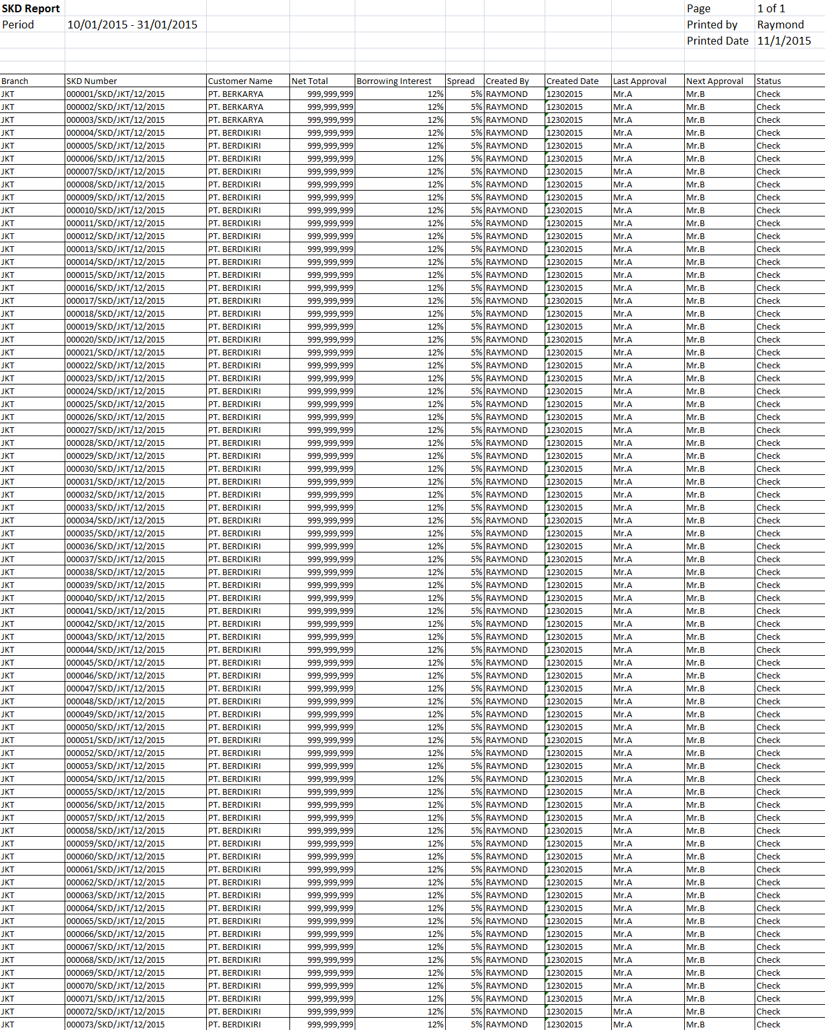

16

15

14

13

12

11

10

5

3

4

2

1

9

8

7

6

**PF.AB.2.1 SKD Form**

|  |  |  |  |  |
| --- | --- | --- | --- | --- |
| *No.* | *Content* | *Description* | *Source* | *Remarks* |
| 1 | Form Title | OPERATING LEASE BOARD OF DIRECTOR APPROVAL |  |  |
| 2 | Product | Operating Lease |  |  |
| 3 | Number | SKD Number | Tb\_MKT\_SKD.SKD Number |  |
| 4 | Customer Name | Customer Name | Customer.CustomerName | *Where*  *Tb\_MKT\_SKD.IdOPLQuotation = OPLQuotation.IdOPLQuotation*  *And*  *OPLQuotation.IdOPLCalculation = OPLCalculation.IdOPLCalculation And*  *OPLCalculation.IdCustomer = Customer.IdCustomer* |
| 5 | Group | Group | Customer.Group |  |
| 6 | Address | Address | Customer.Address |  |
| 7 | Date | SKD Date | Tb\_MKT\_SKD.SKDDate |  |
| 8 | Type of Cars | Model Name Unit | Product.ModelName | *Where*  *Tb\_MKT\_SKD.IdProduct = Product. IdProduct* |
| 9 | Accessories/Carroserrie | Model Name Accessories/Carroserrie | Tb\_MKT\_SKD\_Dtl.Name |  |
| 10 | Year | Model Year | Product.ModelYear | *Where*  *Tb\_MKT\_SKD.IdOPLQuotation = OPLQuotation.IdOPLQuotation*  *And*  *OPLQuotation.IdOPLCalculation = OPLCalculation.IdOPLCalculation*  *And*  *OPLCalculation.IdProduct = Product. IdProduct* |
| 11 | Supplier Name | Supplier Name | Supplier.SupplierName | *Where*  *Tb\_MKT\_SKD.IdSupplier = Supplier. IdSupplier* |
| 12 | Qty | Qty | Tb\_MKT\_SKD\_Dtl.Qty |  |
|  | Unit Price | Unit Price Unit | OPLBasicCondition.ProductPrice | *Where*  *Tb\_MKT\_SKD.IdOPLQuotation = OPLQuotation.IdOPLQuotation*  *And*  *OPLQuotation.IdOPLCalculation = OPLCalculation.IdOPLCalculation And*  *OPLCalculation.IdOPLBasicCondition = OPLBasicCondition. IdOPLBasicCondition* |
|  | Unit Price | Unit Price Accessories/Carroserrie | Tb\_MKT\_SKD\_Dtl.Price |  |
| 13 | Total Price Unit | Total Price Unit |  | *Formula:*  *Qty x Unit Price Unit* |
|  | Total Price Accessories/Carrosserie | Total Price Accessories/Carrosserie |  | *Formula:*  *Qty x Unit Price Accessories/ Carrosserie* |
| 14 | Total Investment | Total Investment |  | *Formula:*  *Total Price Unit + Total Price* Accessories/Carrosserie |
| 15 | VAT IN (n %) | VAT IN (*n*%) | *OPLCalculation.VATRestitution* |  |
| 16 | Net After VAT | Net After VAT |  | *Formula:*  *Total Investment - VAT IN* |
| 17 | *n* unit | Qty | Tb\_MKT\_SKD\_Dtl.Qty |  |
| 18 | Net Investment | Net After VAT |  | *Formula:*  *Total Investment + VAT IN* |
| 19 | Residual Value (% x unit price) | Residual Value (%) | OPLBasicCondition.ResidualValuePercent | *Where*  *Tb\_MKT\_SKD.IdOPLQuotation = OPLQuotation.IdOPLQuotation*  *And*  *OPLQuotation.IdOPLCalculation = OPLCalculation.IdOPLCalculation And*  *OPLCalculation.IdOPLBasicCondition = OPLBasicCondition. IdOPLBasicCondition*  *Formula:*  *Residual Value / Net investment* |
| 20 | Residual Value | Residual Value | OPLBasicCondition.ResidualValueAmount | *Where*  *Tb\_MKT\_SKD.IdOPLQuotation = OPLQuotation.IdOPLQuotation*  *And*  *OPLQuotation.IdOPLCalculation = OPLCalculation.IdOPLCalculation And*  *OPLCalculation.IdOPLBasicCondition = OPLBasicCondition.IdOPLBasicCondition*  *Formula:*  *Residual Value Amount x Qty* |
| 21 | Lease term | Lease Term | OPLCalculation.LeasePeriodPlan | *Where*  *Tb\_MKT\_SKD.IdOPLQuotation = OPLQuotation.IdOPLQuotation*  *And*  *OPLQuotation.IdOPLCalculation = OPLCalculation.IdOPLCalculation* |
| 22 | Monthly Operating Lease | Monthly Operating Lease | OPLCalculation.MonthlyInstallmentAmount | *Where*  *Tb\_MKT\_SKD.IdOPLQuotation = OPLQuotation.IdOPLQuotation*  *And*  *OPLQuotation.IdOPLCalculation = OPLCalculation.IdOPLCalculation*  *Formula :*  *Monthly Installment Amount x Qty* |
| 23 | VAT 10% (+) | VAT 10% (+) |  | *10% x Monthly Operating Lease* |
| 24 | Billing | Billing |  | *Monthly Operating Lease + VAT 10%* |
| 25 | Witholding Tax Art 23 2% | Witholding Tax Art 23 2% |  | *2% x Monthly Operating Lease* |
| 26 | Net Payment | Net Payment |  | *Billing - Witholding Tax Art 23 2%* |
| 27 | *n* month | *n* month | OPLCalculation.LeasePeriodPlan | *Where*  *Tb\_MKT\_SKD.IdOPLQuotation = OPLQuotation.IdOPLQuotation*  *And*  *OPLQuotation.IdOPLCalculation = OPLCalculation.IdOPLCalculation* |
| 28 | Installment Income | Installment Income | OPLCalculation.MonthlyInstallmentAmount \* OPLCalculation.LeasePeriodPlan | *Where*  *Tb\_MKT\_SKD.IdOPLQuotation = OPLQuotation.IdOPLQuotation*  *And*  *OPLQuotation.IdOPLCalculation = OPLCalculation.IdOPLCalculation* |
| 29 | Insurance Income | Insurance Income | OPLCalculation.InsurranceCommisionAmount | *Where*  *Tb\_MKT\_SKD.IdOPLQuotation = OPLQuotation.IdOPLQuotation*  *And*  *OPLQuotation.IdOPLCalculation = OPLCalculation.IdOPLCalculation* |
| 30 | Total Lease Income | Total Lease Income |  | *Installment Income + Insurrance Income* |
| 31 | Product Price | Product Price | OPLBasicCondition.ProductPrice | *Where*  *Tb\_MKT\_SKD.IdOPLQuotation = OPLQuotation.IdOPLQuotation*  *And*  *OPLQuotation.IdOPLCalculation = OPLCalculation.IdOPLCalculation*  *And*  *OPLCalculation.IdOPLBasicCondition = OPLBasicCondition.IdOPLBasicCondition* |
| 32 | Residual Value | Residual Value | OPLBasicCondition.ResidualValueAmount | *Where*  *Tb\_MKT\_SKD.IdOPLQuotation = OPLQuotation.IdOPLQuotation*  *And*  *OPLQuotation.IdOPLCalculation = OPLCalculation.IdOPLCalculation*  *And*  *OPLCalculation.IdOPLBasicCondition = OPLBasicCondition.IdOPLBasicCondition* |
| 33 | Registration | Registration | OPLFinanceCondition.RegistrationValueAmount | *Where*  *Tb\_MKT\_SKD.IdOPLQuotation = OPLQuotation.IdOPLQuotation*  *And*  *OPLQuotation.IdOPLCalcualtion = OPLCalculation.IdOPLCalculation*  *And*  *OPLCalculation.IdOPLFinanceCondition = OPLFinanceCondition.IdOPLFinanceCondition* |
| 34 | Maintenance | Maintenance | OPLMaintenanceCondition.TotalMaintenanceAmount | *Where*  *Tb\_MKT\_SKD.IdOPLQuotation = OPLQuotation.IdOPLQuotation*  *And*  *OPLQuotation.IdOPLCalculation = OPLCalculation.IdOPLCalculation*  *And*  *OPLCalculation.IdOPLMaintenanceCondition = OPLMaintenanceCondition.IdOPLMaintenanceCondition* |
| 35 | Replacement | Replacement | OPLFinanceCondition.ReplacementCarAmount \* OPLCalculation.LeasePeriodPlan | *Where*  *Tb\_MKT\_SKD.IdOPLQuotation = OPLQuotation.IdOPLQuotation*  *And*  *OPLQuotation.IdOPLCalculation = OPLCalculation.IdOPLCalculation*  *And*  *OPLCalculation.IdOPLFinanceCondition = OPLFinanceCondition.IdOPLFinanceCondition*  *Where*  *Tb\_MKT\_SKD.IdOPLQuotation = OPLQuotation.IdOPLQuotation*  *And*  *OPLQuotation.IdOPLCalculation = OPLCalculation.IdOPLCalculation*  *Formula:*  *OPLFinanceCondition.ReplacementCarAmount \* OPLCalculation.LeasePeriodPlan \* Qty* |
| 36 | Insurance Cost | Insurance Cost | OPLInsuranceCondition.TotalGrossPremium + Rp 20.000 | *Where*  *Tb\_MKT\_SKD.IdOPLQuotation = OPLQuotation.IdOPLQuotation*  *And*  *OPLQuotation.IdOPLCalculation = OPLCalculation.IdOPLCalculation*  *And*  *OPLCalculation.IdOPLInsuranceCondition = OPLInsuranceCondition.IdOPLInsuranceCondition* |
| 37 | Mediator Fee | Mediator Fee | OPLInsuranceCondition.MediatorFeeAmount | *Where*  *Tb\_MKT\_SKD.IdOPLQuotation = OPLQuotation.IdOPLQuotation*  *And*  *OPLQuotation.IdOPLCalculation = OPLCalculation.IdOPLCalculation And*  *OPLCalculation.IdOPLInsuranceCondition = OPLInsuranceCondition.IdOPLInsuranceCondition* |
| 38 | Mobilization | Mobilization | OPLFinanceCondition.MobilizationFeeAmount | *Where*  *Tb\_MKT\_SKD.IdOPLQuotation = OPLQuotation.IdOPLQuotation*  *And*  *OPLQuotation.IdOPLCalculation = OPLCalculation.IdOPLCalculation And*  *OPLCalculation.IdOPLFinanceCondition = OPLFinanceCondition.IdOPLFinanceCondition* |
| 39 | DeMobilization | DeMobilization | OPLFinanceCondition.DeMobilizationFeeAmount | *Where*  *Tb\_MKT\_SKD.IdOPLQuotation = OPLQuotation.IdOPLQuotation*  *And*  *OPLQuotation.IdOPLCalculation = OPLCalculation.IdOPLCalculation And*  *OPLCalculation.IdOPLFinanceCondition = OPLFinanceCondition.IdOPLFinanceCondition* |
| 40 | Interest Cost | Interest Cost | OPLCalculation.InterestExpense | *Where*  *Tb\_MKT\_SKD.IdOPLQuotation = OPLQuotation.IdOPLQuotation*  *And*  *OPLQuotation.IdOPLCalculation = OPLCalculation.IdOPLCalculation* |
| 41 | Term of Payment Cost | Term of Payment Cost | OPLFinanceCondition.TermPaymentDays \* (OPLBasicCondition.ProductPriceTotal + OPLBasicCondition.AccesoriesPriceTotal + OPLBasicCondition.CarroserriePriceTotal) \* (OPLFinanceCondition.BorrowingFlatPercent / 100) / 360 | *Where*  *Tb\_MKT\_SKD.IdOPLQuotation = OPLQuotation.IdOPLQuotation*  *And*  *OPLQuotation.IdOPLCalculation = OPLCalculation.IdOPLCalculation And*  *OPLCalculation.IdOPLFinanceCondition = OPLFinanceCondition.IdOPLFinanceCondition*  *Where*  *Tb\_MKT\_SKD.IdOPLQuotation = OPLQuotation.IdOPLQuotation*  *And*  *OPLQuotation.IdOPLCalculation = OPLCalculation.IdOPLCalculation And*  *OPLCalculation.IdOPLBasicCondition = OPLBasicCondition.IdOPLBasicCondition* |
| 42 | Interest Cost before BAST | Interest Cost before BAST | OPLCalculation.InterestExpenseBAST | *Where*  *Tb\_MKT\_SKD.IdOPLQuotation = OPLQuotation.IdOPLQuotation*  *And*  *OPLQuotation.IdOPLCalculation = OPLCalculation.IdOPLCalculation* |
| 43 | Total Lease Cost | Total Lease Cost |  | *Formula:*  *Product Price+Residual Value+Registration+Maintenance+Replacement+Insurance Cost+Mediator Fee+Mobilization+DeMobilization+Interest Cost+Term of Payment Cost+Interest Cost before BAST* |
| 44 | Income – Cost | Income – Cost |  | *Formula :*  *Total Lease Income – Total Lease Cost* |
| 45 | VAT IN | VAT IN | OPLCalculation.VATRestitution | *Where*  *Tb\_MKT\_SKD.IdOPLQuotation = OPLQuotation.IdOPLQuotation*  *And*  *OPLQuotation.IdOPLCalculation = OPLCalculation.IdOPLCalculation* |
| 46 | Net After Tax | Net After Tax |  | *Formula:*  *(Income – Cost) + VAT IN* |
| 47 | Borrowing Interest | Borrowing Interest | OPLFinanceCondition.BorrowingEffectivePercent | *Where*  *Tb\_MKT\_SKD.IdOPLQuotation = OPLQuotation.IdOPLQuotation*  *And*  *OPLQuotation.IdOPLCalculation = OPLCalculation.IdOPLCalculation And*  *OPLCalculation.IdOPLFinanceCondition = OPLFinanceCondition.IdOPLFinanceCondition* |
| 48 | Spread | Spread | OPLFinanceCondition.SpreadEffectivePercent | *Where*  *Tb\_MKT\_SKD.IdOPLQuotation = OPLQuotation.IdOPLQuotation*  *And*  *OPLQuotation.IdOPLCalculation = OPLCalculation.IdOPLCalculation And*  *OPLCalculation.IdOPLFinanceCondition = OPLFinanceCondition.IdOPLFinanceCondition* |
| 49 | Payment Type | Payment Type | OPLFinanceCondition.PaymentType | *Where*  *Tb\_MKT\_SKD.IdOPLQuotation = OPLQuotation.IdOPLQuotation*  *And*  *OPLQuotation.IdOPLCalculation = OPLCalculation.IdOPLCalculation And*  *OPLCalculation.IdOPLFinanceCondition = OPLFinanceCondition.IdOPLFinanceCondition* |
| 50 | Payment Mode | Payment Mode | Tb\_MKT\_SKD.PaymentMode |  |
| 51 | Note | Note | Tb\_MKT\_SKD.Note |  |
| 52 | Approval | Approval |  | *Refer to FC.C.1.1 System Setting – Setting Approval Path*   * *Prepared By : Marketing Officer* * *Acknowledged By/ Approved By (from left to right) : Head of Branch/ Head of Department, Regional Manager, Advisor, Director, President Director, Shareholder’s Meeting* |
| 53 | Keterangan | SKD O/S Investment |  |  |
| 54 | Customer Name | Customer Name | Customer.CustomerName |  |
| 55 | Harga | Net After VAT |  | *Formula :*  *= Net After VAT* |
| 56 | RV | Residual Value | OPLBasicCondition.ResidualValueAmount | *Where*  *Tb\_MKT\_SKD.IdOPLQuotation = OPLQuotation.IdOPLQuotation*  *And*  *OPLQuotation.IdOPLCalculation = OPLCalculation.IdOPLCalculation And*  *OPLCalculation.IdOPLBasicCondition = OPLBasicCondition.IdOPLBasicCondition* |
| 57 | Net | Net Investment |  | *Formula :*  *Net After VAT – Residual Value Amount* |

**PF.AB.2.1 SKD Form**



1

52

57

56

55

54

53

51

50

49

48

47

8

6

5

4

3

2

46

45

44

43

42

41

40

39

38

37

36

35

34

33

32

31

29

28

30

26

24

25

23

22

21

20

19

18

27

17

16

15

14

13

11

12

10

9

7

**ERD Structure**

